arXiv:2606.04777v2 [cs.LG] 4 Jun 2026

UniFair: A unified fair clustering approach based on separation and compactness

Antonia Karra¹, Vasiliki Papanikou^{1,2}, Georgios Vardakas¹, Evaggelia Pitoura^{1,2}, and Aristidis Likas¹
1
University of Ioannina, Greece {a.karra, v.papanikou, g.vardakas, pitoura,
arly.cs}@uoi.gr
2
Archimedes/Athena Research Center, Greece

Abstract. Clustering is increasingly used to support high-impact de- cisions, yet standard objectives such as k-means can produce cluster- ings that treat demographic groups unequally. Existing fair clustering methods typically optimize a single notion of fairness and often overlook how clustering costs interact with the geometry of the induced deci- sion boundaries. We propose UniFair, a unified framework that jointly optimizes separation fairness and social fairness. Separation fairness en- courages protected groups to lie farther from the induced decision bound- aries, while social fairness reduces disparities in within-cluster distortion by penalizing group-wise clustering costs. We develop gradient-based op- timization procedures for separation-fair and unified k-means objectives, and extend them to deep clustering by enforcing the same criteria in the latent space of an autoencoder. Experiments on tabular and image datasets show that UniFair reduces both boundary-related and cost- based group disparities with only a modest increase in clustering loss.

Keywords: Fair clustering · k-mean clustering · algorithmic fairness.

Introduction

Clustering is a core task in data analysis and machine learning, widely used for exploration, profiling, and as a building block for downstream decision sup- port. In settings involving protected groups, standard clustering objectives can produce clusters that treat groups unequally, even when the overall clustering
quality is high [ . Since the induced partition shapes later processing
1,7 |  | ,6,1 | 1]

and decisions, group-level disparities in the resulting clusters can propagate to subsequent analyses and workflows.
Recent research on fair clustering proposes multiple fairness notions [5]. One line of research aims to balance group proportions within clusters [2,6] and to provide guarantees on group presence across clusters [10]. Another line of re- search enforces a form of social fairness by controlling the clustering costs in- curred by each group [1,7]. However, disparities may also arise from how decision boundaries intersect groups. Two groups may incur similar clustering costs while one lies systematically closer to cluster boundaries, making its assignments more

sensitive to small perturbations. This boundary-proximity effect captures a ge- ometric source of disparity that is not reflected by distortion alone.
To address this gap, we introduce separation fairness, a boundary-aware group fairness notion that encourages protected groups to lie farther away from their closest decision boundaries. Our formulation builds on a counterfactual- distance view of boundary proximity: for each point, we measure the minimum perturbation required to reach the nearest separating hyperplane between its as- signed centroid and its closest competing centroid. Separation fairness improves the least-separated group by maximizing its average distance to the decision boundary. This notion is complementary to cost-based fairness objectives: it tar- gets the geometry of the partition rather than only the compactness of clusters. We focus on k-means clustering, but our notion is applicable to other clustering objectives that induce well-defined decision boundaries between clusters.
Building on separation fairness, we propose UniFair. UniFair couples a separation-fairness term with a social-fairness term, thereby capturing two com- plementary sources of disparity: proximity to the induced decision boundaries and disparities in within-cluster distortion. We develop Lloyd-style alternating procedures, augmented with fairness-aware centroid updates, for (i) a separation fair k-means objective and (ii) the unified UniFair objective. Our updates pre- serve the standard assignment–update structure of k-means while incorporating additional terms that (a) push groups farther from induced decision boundaries and (b) penalize group-wise clustering costs. To support high-dimensional data, we further extend the unified objective to a deep latent-space setting via an autoencoder, enabling joint optimization of reconstruction error, latent com- pactness, and fairness regularization terms.
Our empirical evaluation on tabular and image datasets demonstrates that optimizing separation fairness increases the minimum group separation from in- duced decision boundaries, while UniFair achieves strong joint improvements reducing both boundary-related and cost-based group disparities with only a modest increase in clustering loss. We further show that separation fairness and social fairness capture complementary aspects of unfairness, and that our algo- rithm provides a flexible way to balance the two fairness notions through the fairness weights, while remaining competitive with existing fair clustering and deep fair clustering methods.
The rest of this paper is structured as follows: Section 2 reviews related work. Section 3 introduces separation fairness and the unified objective, while Section 4 presents the separation and the UniFair algorithms. Section 5 presents our experimental evaluation, and Section 6 concludes the paper.

Related Work

Fairness in clustering has received considerable attention in recent years [5]. At
a high level, fairness notions in clustering can be divided into individual and group fairness. Individual fairness approaches, e.g., [3,9], require that similar individuals receive similar cluster assignments, regardless of group membership.

Group fairness approaches, in contrast, impose fairness requirements at the level of protected groups. Our work belongs to the latter category.
Several notions have been proposed to formalize group fairness in cluster- ing, including balance-based, representation-based, and social-based approaches.
Balance-based fairness, e.g., [ ], seeks to preserve the proportion of in-
6,2 |  | ,13,4

dividuals from each protected group within clusters, thereby avoiding over- or under-representation. Minimum representation-based fairness, e.g., [10], requires that each group attain a sufficient level of representation in the clusters.
The line of work most closely related to ours is social fairness in clustering. Rather than focusing on cluster composition, social fairness focuses on whether the quality of the clustering outcome is distributed fairly across groups. This is typically captured through group-aware clustering objectives based on the distances of points to their assigned centers, with the goal of preventing some groups from systematically receiving worse clustering losses than others. So- cially fair k-means [7] extends the standard k-means objective by optimizing a fairness-aware aggregation of group-specific costs, thus emphasizing the worst- off groups. The method follows a Lloyd-style iterative refinement procedure with fairness-aware group-level objectives. A related formulation is equitable group representation clustering [1], which evaluates fairness through how well the se- lected centers represent the data distribution of each group, introducing absolute and relative representation errors to quantify group-wise disparities. Subsequent work has further advanced this direction by developing improved approximation algorithms for group-fair clustering objectives, e.g., [12,8].
Our work captures a different aspect of group unfairness. Whereas social- fairness focus on group-wise clustering quality, we focus on group-wise separation. Specifically, we ask whether points from some groups are systematically closer to cluster boundaries, and are therefore more likely to change assignment under small perturbations. Thus, our notion captures disparities in assignment stability across groups, rather than disparities in group-wise clustering quality.
Finally, deep fair clustering incorporates fairness constraints into deep rep- resentation learning. Fairoids [15] introduces fairness reference points defined as the average latent embeddings of the protected groups. It encourages cluster centroids to remain equidistant from these fairoids and reduces distributional disparities using Maximum Mean Discrepancy (MMD). The work in [16] further develops this direction by combining probabilistic discriminative clustering with integer linear programming constraints to enforce group-level fairness. Similarly, the deep fair clustering approach (DFC) in [11] promotes statistical indepen- dence between cluster assignments and sensitive attributes through an adversar- ial learning framework that combines fairness-adversarial, structure-preserving, and clustering regularization losses.
Overall, these deep fair clustering approaches primarily focus on equitable representation or independence with respect to sensitive attributes, rather than on social cost and separation fairness.

Separation and Unified Fairness
Let X = {x₁, . . . , x_{N} } ⊂ R^{d} denote the dataset. We assume that the data points
are partitioned into m groups X_{g}, 1 ≤ g ≤ m. Let M = {µ₁, µ₂, . . . , µ_{k}} denote
the set of k cluster centroids and let L(M ) = ¹ Pk P ∥x − µ ∥² be the

clustering cost.
|X|
j=1
x∈Cj j

Previous research on fairness for clustering has mainly focused on the clus- tering cost for each group. Specifically, for each group X_{g}, 1 ≤ g ≤ m, the group-wise clustering cost is defined as:

L_{g}(M ) =
1 Xk

X
∥x − µ_{j}∥². (1)

|Xg | j=1 x∈C ∩X
j
g

Social fairness introduced in [7] focuses on the clustering cost incurred for each group. Specifically, social fairness focuses on the the maximum group-wise clustering cost incurred by any of the groups.
Definition 1 (Social Cost). The social cost of clustering M is the maximum group-wise clustering cost:

Soc(M ) = max
1≤g≤m
L_{g}(M ). (2)

Social cost admits a complementary interpretation. Clustering naturally in-
duces a local partition of each group within each cluster. For each clPuster C_{j} and

group X_{g}, 1 ≤ g ≤ m, we define its group mean as: µ_{j,g} = ¹
|Cj ∩X |g
x∈Cj ∩Xg x.

The subgroup mean describes how the group is represented locally inside cluster
C_{j}. The inner sum of Eq. 1 can be written as:

X

x∈Cj ∩Xg
X
∥x − µ_{j}∥² =
x∈Cj ∩Xg
∥x − µ_{j,g}∥² + |C_{j} ∩ X_{g}| ∥µ_{j} − µ_{j,g}∥². (3)

The second term shows that minimizing L_{g} encourages each centroid µ_{j} to align with the subgroup mean µ_{j,g}, while the first term captures within-group dispersion.
Social fairness controls within-cluster distortion across groups; however, it does not directly control how close each group lies to the induced decision boundaries. As shown in Figure 1(b), two groups may incur similar group-wise clustering costs, while one group lies closer to the cluster boundary than the other. Points close to a boundary can change clusters under relatively small perturbations, whereas points farther away require larger changes. In many ap- plications, cluster assignments influence downstream decisions, such as resource allocation, profiling, or recommendation. If members of one group are system- atically closer to decision boundaries, their assignments become more sensitive to small perturbations or noise. This can result in higher instability or volatility of the outcomes for that group. We therefore introduce separation fairness to explicitly quantify group-level separation from decision boundaries. Separation

fairness complements distortion-based notions by capturing a geometric aspect of fairness that is not reflected by within-cluster distortion alone.
The centroids M = {µ₁, . . . , µ_{k}} induce a Voronoi partition of R^{d}, where each cluster C_{j} corresponds to the Voronoi cell

C_{j} = {x ∈ R^{d} : ∥x − µ_{j}∥ ≤ ∥x − µ_{ℓ}∥, ∀ℓ ̸= j}.
Decision boundaries between clusters are therefore Voronoi bisectors between pairs of centroids.
For a point x, let µ_{j}1(x) and µ_{j}2(x) denote its two closest centroids. The relevant decision boundary is the Voronoi bisector between these two centroids,
consisting of all points z satisfying ∥z − µ_{j} _{(x)}∥² = ∥z − µ_{j} _{(x)}∥². This bisector
1 2
is a hyperplane passing through the midpoint m(x) = ¹ (µ_{j} _{(x)} + µ_{j} _{(x)}) and

orthogonal to v(x) = µ_{j}2(x) − µ_{j}1(x).
2 1 2

We define the counterfactual distance of x as its squared Euclidean distance

to this Voronoi bisector: dist²(x) =
(x − m(x))⊤
2
vˆ(x)
, where vˆ(x) = ^{v(x)} .

This quantity corresponds to the squared Voronoi margin of x. Intuitively, this
∥v(x)∥
captures how stable a cluster assignment is for a point: points close to the de- cision boundary can switch clusters under small perturbations, whereas points farther away require larger changes. We call this distance counterfactual because it measures the smallest perturbation that would change the cluster assignment for the point (factual), aligning with counterfactual explanations (CFE) for clus- tering [14]. We use squared boundary distance for consistency with the squared k-means objective and to obtain smooth gradients within the assignment regions.
An example of counterfactual distances is shown in Figure 1 (a).
Let d₁(x) = ∥x − µ_{j}1(x)∥ and d₂(x) = ∥x − µ_{j}2(x)∥ denote the distances to the closest and second-closest centroids, respectively . The counterfactual distance
d²(x)−d²(x) 2

can then be written as: dist²(x) =
2 1 , which highlights its inter-
4∥µj2(x)−µj1(x)∥2

pretation as a normalized geometric margin between the two closest centroids.
The above expression is invariant to translations and rotations. Under uniform scaling by a factor s > 0, it scales as dist²(x) 7→ s² dist²(x), consistent with the squared k-means objective. Normalization by ∥µ_{j} _{(x)} − µ_{j} _{(x)}∥² ensures that separation is measured relative to centroid spacing.
2 1
Note that although the counterfactual distance is expressed in terms of the Voronoi structure induced by k-means, the notion of separation fairness applies to any nearest-centroid partition, and can be extended to alternative clustering models that admit well-defined decision boundaries.
For each subgroup X_{g}, 1 ≤ g ≤ m, we define the group counterfactual distance
as the average of the counterfactual distances of its group members:

1 X
cfd (M ) =

⊤ 2

(4)

^{g} |X_{g}|

x∈Xg
(x − m(x))
vˆ(x) .

We use the average margin to capture typical assignment stability within each group, avoiding sensitivity to isolated boundary points.

We use group counterfactual distances to define separation fairness. Our ob- jective is to improve the boundary separation of the group that is currently least separated from the induced decision boundaries.

Definition 2 (Separation Fairness). Separation fairness of clustering M is:

Sep(M ) = min
1≤g≤m
cfd_{g}(M ). (5)

Using the minimum yields a worst-group fairness criterion: maximizing Sep(M ) improves the average boundary distance of the group that is currently most ex- posed to assignment instability. Figure 1(c) shows a clustering that is separation fair but social unfair, illustrating the complementarity of the two fairness per- spectives.
We now combine both criteria: encouraging greater separation from induced decision boundaries (separation fairness) and reducing disparities in within- cluster distortion across groups (social fairness).

Definition 3 (UniFair clustering objective). We minimize the following objective over centroids M and assignments c(·):

UniF (M ) =
1 XN

N
i=1

∥x_{i} − µ_{c} ∥² + λ_{soc} Soc(M ) − λ_{sep} Sep(M ). (6)

The first term preserves overall clustering quality by minimizing within- cluster distortion. The second term penalizes the worst-group distortion, thereby reducing imbalance in clustering loss across groups, while the third term pro- motes separation by increasing the minimum group margin. The weights λ_{soc} and λ_{sep} control the trade-off between distortion and separation, which are ex- pressed on comparable squared-distance scales. Separation fairness complements loss-based criteria by promoting greater separation from the induced decision boundaries, a property not captured by distortion alone. By coupling separation with distortion minimization, the objective discourages trivial solutions that in- crease boundary separation only by excessively spreading centroids, since such configurations incur higher clustering losses.
i

Algorithms

In this section, we start by presenting our algorithm for separation fairness, and then extend the algorithm to satisfy the unified objective. Finally, we present a deep fair clustering approach.

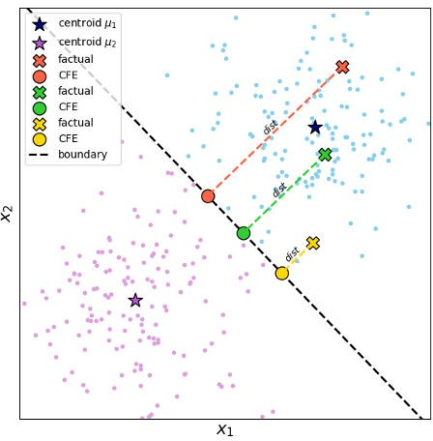
Fig. 1: (a) Example of counterfactual distances. (b) Socially fair but separation unfair clustering. (c) Separation fair but socially unfair clustering.

Algorithm 1 Separation Fair k-means Algorithm

Require: Dataset X, groups Xg for 1 ≤ g ≤ m, number of clusters k, number of iterations T , learning rate η, fairness weight λsep
1: Initialize centroids M = {µ₁, µ₂, . . . , µ_{k}}
2: for t = 1 to T do
3: Assignment step: Assign each point to its closest centroid:

2
c(x) = arg min ∥x − µj ∥ .
j

4: Form clusters Cj = {x ∈ X : c(x) = j}.
5: Fairness evaluation: Compute cfdg (M ), for each group g, 1 ≤ g ≤ m. 6: Select the active group:

G = arg min
1≤g≤m
cfdg (M ).

7: Gradient computation:
8: Compute ∇_{µ}j L_{k-means} from the standard k-means cost using Eq. (8). 9: Compute ∇µj cfdG(M ) using Eq. (10).
10: Centroid update:

µj ← µj − η

11: end for
∇µj Lk-means − λsep∇µj cfdG(M )
, ∀j ∈ {1, . . . , k}.

12: return Final centroids M and assignments c(·).

Separation Fair k-means Algorithm

We propose a separation fair k-means algorithm that jointly optimizes clustering quality and separation fairness. Specifically, we optimize the clustering-quality

term together with the separation-fairness term Sep(M ) of Definition 3:

1 XN

SepF (M ) =
i
N

i=1
∥x_{i} − µ_{c} ∥² − λ_{sep} Sep(M ). (7)

Algorithm 1 proceeds iteratively by first recomputing the cluster assignments and then updating the centroids using the combined gradient of the k-means cost and the separation-fairness term for the currently worst-off group. Since assignments and the identities of the two closest centroids can change across iterations, the overall objective is piecewise smooth; we therefore view the pro- cedure as an alternating heuristic in the spirit of the Lloyd algorithm, augmented with fairness-aware centroid updates. We next derive the gradients used in the centroid update step.

Gradient of the k-means loss term. For each centroid µ_{j}, the gradient of the k-means loss term is:

2
∇µj Lk-means = N
X

x∈Cj

(µ_{j} − x). (8)

Gradient of the separation fairness term. For each group X_{g}, 1 ≤ g ≤ m,

we define: cfd (M ) = ¹ P
⊤ 2

g |Xg |
x∈Xg r(x; M ), where r(x; M ) =
(x−m(x)) vˆ(x) ,

, m(x) is the midpoint between the two closest centroids to x, and vˆ(x) is the
unit vector pointing from the closest centroid to the second closest centroid. For a single point x, we define: s(x) = vˆ(x)⊤(x−m(x)), where P (x) = I −vˆ(x)vˆ(x)⊤.
Let j₁(x) and j₂(x) denote the indices of the two centroids closest to x. For
a fixed nearest-centroid configuration, the gradients of r(x; M ) with respect to
these centroids are:

∇µj1(x)
r(x) = 2 s(x)
1
−
∥v(x)∥
P (x) (x − m(x)) − ¹ vˆ(x) ,
2

(9)

∇µj2(x)
r(x) = 2 s(x)
1

∥v(x)∥
2
P (x) (x − m(x)) − ¹ vˆ(x) .

While for all remaining centroids, ∇_{µ}j r(x) = 0 for j ∈/ {j₁(x), j₂(x)}.
Averaging over the points in group X_{g} yields:

∇_{µ}j cfd_{g}(M ) =
1

|X_{g}|
X

x∈Xg

1{j = j₁(x)} + 1{j = j₂(x)}

∇_{µ}j r(x). (10)

Therefore, at each iteration, the fairness-aware update increases the average counterfactual distance of the currently worst-off group (under the current as- signment and nearest-centroid configuration), while the k-means term promotes cluster compactness. Compared to vanilla k-means, the additional computation amounts to identifying the two closest centroids for each point and accumulating the corresponding group-wise gradients.

UniFair k-means Algorithm
We now extend our algorithm to incorporate the social fairness Soc(M ) term. First, we show how a similar active-group approach can be used to incorporate the social fairness term, yielding the following objective:

1 XN

SocF (M ) =
i
N

i=1
∥x_{i} − µ_{c} ∥² + λ_{soc} Soc(M ). (11)

First, we derive the gradient of the social fairness term.

Gradient of the social fairness term. Let the worst-off group be:

G = arg max
1≤g≤m
L_{g}(M ).

Then the active fairness gradient is

2
∇_{µ}j L_{g}(M ) = |X |
g
X

x∈Cj ∩Xg

(µ_{j} − x) =
2|Cj ∩ Xg | (µ − µ ), (12)
|Xg | j j,g

which shows that the fairness penalty pulls µ_{j} toward the subgroup mean µ_{j,G}
of the group currently incurring the highest clustering cost.
The Social Fair k-means algorithm works similarly to Algorithm 1. The only differences are: (1) in the fairness evaluation step (Lines 5-6), we select the worst group G based on social cost, (2) in line (9), we compute ∇_{µ}j L_{g}(M ) using Eq. (12), and (3) the centroid update (Line 10) uses:

µ_{j} ← µ_{j} − η
∇µj Lk-means + λsoc · ∇µj LG(M ) .

We now present the UniFair k-means algorithm (Algorithm 2) that mini- mizes the unified objective.

Algorithm 2 UniFair k-means Algorithm

Require: Dataset X, groups Xg for 1 ≤ g ≤ m, number of clusters k, number of iterations T , learning rate η, fairness weights λsoc, λsep
1: Initialize centroids M = {µ₁, µ₂, . . . , µ_{k}}
2: for i = 1 to T do
2
3: Assign c(x) = arg minj ∥x − µj ∥ and form clusters Cj
4: Compute Lg (M ) and cfdg (M ) for each group 1 ≤ g ≤ m
5: Active groups: H = arg max_{1≤g≤m} L_{g}(M ), G = arg min_{1≤g≤m} cfd_{g}(M )
6: Update centroids

µj ← µj − η
∇µj Lk-means + λsoc∇µj LH (M ) − λsep∇µj cfdG(M )
, ∀j

7: end for
8: return M and assignments c(·)

Increasing λ_{sep} emphasizes separation fairness by increasing min_{g} cfd_{g}(M ), while increasing λ_{soc} emphasizes social fairness by reducing the worst group-wise loss max_{g} L_{g}(M ), typically at some cost in overall distortion. When both terms are active, the method jointly trades off cluster compactness, group-wise distor- tion disparities, and group-level separation from induced decision boundaries.

Deep Fair Clustering

We extend the fairness-aware objective into a deep learning framework to support high dimensional non tabular data. The key idea is to integrate fairness regu- larization terms into the latent space learned by an autoencoder (AE), enabling the joint optimization of reconstruction, clustering compactness, and fairness. The encoder E_{ϕ} maps the input x_{i} into a latent embedding z_{i} = E_{ϕ}(x_{i}), where fairness constraints are applied, while the decoder D_{ψ} reconstructs the input to preserve information fidelity. The total loss takes the general form

Ltotal = α Lrec + β Lcmp + λ Lfair, (13)

where L_{rec} is the autoencoder reconstruction loss that ensures reconstruction quality, L_{cmp} is the latent space k-means that enforces clustering compactness in latent space, and L_{fair} represents a fairness-specific regularization term. The coefficients α and β control the relative importance of the reconstruction and
clustering objectives, respectively, while λ determines the strength of the fairness regularization. Depending on the fairness criterion, L_{fair} takes a different form, leading to three variants described below.

Deep Separation Fair Clustering. We enforce separation fairness directly in latent space. For each group g, let Z_{g} = {z_{i} : x_{i} ∈ X_{g}} denote the embeddings of points in group g. For each z_{i}, let µ_{a}i and µ_{b}i denote its closest and second-closest latent centroids, respectively, and let r(z_{i}; M ) be the (squared) distance of z_{i} to the induced decision boundary, defined as in Section 3:

r(z ; M ) =

∥z_{i}

- µ_{b}i

∥² − ∥z_{i}

- µ_{a}i
∥2 2
.

^{i} 4∥µ_{a}
i
- µ_{b}i ∥2

The group counterfactual distance in latent space is then

cfd_{g}(Z) =

1

|Z_{g}|
X

zi∈Zg

r(z_{i}; M ), Sep(Z) = min
1≤g≤m

cfd_{g}(Z).

The deep separation-fair objective rewards larger worst-group separation from the induced decision boundaries:

L_{sep} = α L_{rec} + β L_{cmp} − λ_{sep} Sep(Z). (14)

Deep UniFair Clustering. We now incorporate the social fairness term in the latent space. For each group g, define the group-wise latent clustering loss

1
L (Z) =
X
∥z − µ

∥², Soc(Z) = max L (Z).

^{g} |Z_{g}|
i
zi∈Zg
c(zi)
g
1≤g≤m

Combining social and separation fairness yields the deep UniFair objective:
L_{UniFair} = α L_{rec} + β L_{cmp} + λ_{soc} Soc(Z) − λ_{sep} Sep(Z). (15)
This objective is the latent-space analogue of the classical UniFair formu- lation, simultaneously penalizing worst-group distortion and rewarding worst- group separation from induced decision boundaries. The weights λ_{soc} and λ_{sep} control the trade-off between the two criteria.

Experimental Evaluation

For our experiments, we use four tabular datasets commonly used in fairness evaluation for clustering: Adult, Student, Bank, and Credit³. Adult contains de- mographic and income information, Credit includes financial and behavioral at- tributes of credit card clients, Bank consists of marketing and demographic data from bank campaigns, and Student contains academic and personal background information. For Adult and Student we use sex as the protected attribute, while for Bank and Credit we use marital status. For deep fair clustering, we use the MNIST–USPS digit datasets⁴ , as well as the Color Reverse MNIST dataset, where image colors are inverted. In MNIST–USPS, the dataset origin (MNIST or USPS) serves as the protected attribute, while in Color Reverse MNIST the image color (original or reversed) is treated as the protected attribute.
For tabular datasets, we use k = 7 clusters for Adult and k = 5 for the others. The number of clusters is selected based on the silhouette score. Optimization runs for 500 iterations with learning rate 0.01, and experiments are repeated over 10 random seeds.For deep clustering, we use k = 10 clusters and a fully connected autoencoder with latent dimension 20 and LeakyReLU activations. The model is pretrained for 50 epochs (learning rate 10⁻³) and then trained for clustering for
50 epochs (learning rate 5 · 10⁻⁵). The reconstruction and compactness weights are set to α = β = 1.0. Our code is available online⁵.
Through our experiments we address the following research questions:

- RQ1: What is the relationship between separation and social fairness?
- RQ2: Does jointly optimizing separation and social fairness lead to better overall equity?
- RQ3: How does UniFair perform on multidimensional data?
³ Adult, Student, Bank, and
4
5
GitHub code
USPS
,
MNIST
Credit

RQ1: What is the relationship between separation and social fair- ness?
In this research question, we investigate the relationship between separation fairness and social fairness. To this end, we evaluate both separation fair k- means and social fair k-means for different values of the fairness parameter λ, where λ = λ_{sep} = λ_{soc} and we record the k-means clustering cost, the separation fairness, and the social fairness cost. The results for all datasets are presented in Figure 2. This experiment allows us to analyze two aspects. First, it reveals the trade-off between clustering quality and fairness as the fairness parameter increases. Second, it allows us to examine the interaction between the two fairness notions by observing how social fairness behaves when optimizing separation fairness, and conversely how separation fairness changes when optimizing social fairness.

6.00

5.80
k-means cost

5.60

5.40

5.20

1.50

1.40
Separation fairness

1.30

1.20

1.10

1.00

0.90

6.60

6.40
Social cost

6.20

6.00

5.80

5.60

Adult
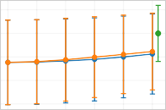

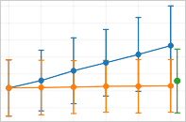

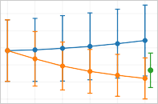
0 0.2 0.4 0.6 0.8 1

22.60

22.50

22.40

22.30

22.20

1.80

1.70

1.60

1.50

1.40

1.30

1.20

1.10

23.60

23.40

23.20

23.00

22.80

22.60

22.40

Student
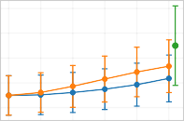

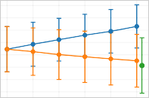

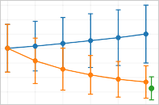
0 0.2 0.4 0.6 0.8 1

1.20

1.15

1.10

1.05

1.00

0.90

0.80

0.70

1.30

1.25

1.20

1.15

1.10

1.05

Bank
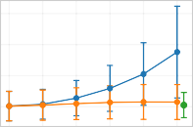

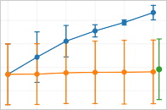

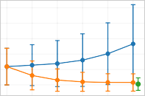
0 0.2 0.4 0.6 0.8 1

9.75

9.50

9.25

9.00

8.75

8.50

8.25

8.00

6.00

4.00

2.00

11.50

11.00

10.50

10.00

9.50

9.00

Credit
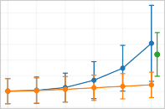

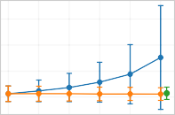

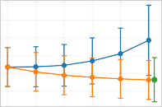
0 0.2 0.4 0.6 0.8 1

Separation fair k-means Social fair k-means Fair-Lloyd

Fig. 2: k-means cost and fairness costs for separation fair k-means, social fair
k-means and Fair-Lloyd across datasets and λ values.

The results show that increasing the fairness parameter λ has a limited im- pact on clustering performance as the k-means cost increases slightly when op- timizing separation fairness, while for social fair k-means it remains nearly con- stant in most datasets. Also, we see that the two fairness notions capture differ- ent types of unfairness. Optimizing separation fairness improves the separation fairness as λ increases, moving points from disadvantaged groups further from cluster decision boundaries, but may slightly increase the social cost. Conversely, optimizing social fairness reduces the maximum social cost, leading to a more balanced clustering cost across demographic groups, while sometimes slightly worsening separation fairness.

0.35
Separation fairness gap

0.30

0.25

0.20

0.15

0.10

0.05

0.00

1.75

1.50
Social fairness gap

1.25

1.00

0.75

0.50

0.25

0.00

Adult
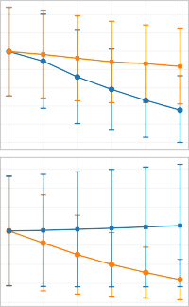
0 0.2 0.4 0.6 0.8 1

0.50

0.40

0.30

0.20

0.10

0.00

3.00

2.50

2.00

1.50

1.00

0.50

Credit
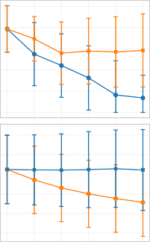
0 0.2 0.4 0.6 0.8 1

0.40

0.30

0.20

0.10

0.00

0.18

0.15

0.13

0.10

0.08

0.05

0.03

0.00

Bank
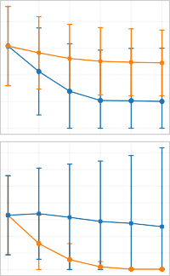
0 0.2 0.4 0.6 0.8 1

0.70

0.60

0.50

0.40

0.30

0.20

2.00

1.75

1.50

1.25

1.00

0.75

0.50

0.25

0.00

Student
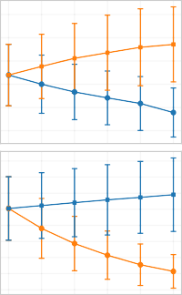
0 0.2 0.4 0.6 0.8 1

Separation Fair k-means
Social Fair k-means

Fig. 3: Separation and social fairness gaps in case of separation fair k-means and social fair k-means across datasets and λ values .

In addition, in Figure 3 we report the separation fairness gap and social fair- ness gap for both algorithms. Although these quantities are not directly opti- mized by the objectives, they provide additional insight into disparities between demographic groups. We observe that the separation fair k-means algorithm steadily reduces the separation fairness gap as λ increases, indicating that the distances of the two demographic groups from the cluster decision boundaries become more balanced. In contrast, the social fairness gap remains relatively stable and in some cases increases slightly. Similarly, when optimizing social fair k-means, the social fairness gap decreases across most datasets, while the sep- aration fairness gap remains largely stable. Overall, these results suggest that separation fairness and social fairness capture complementary aspects of fairness, and optimizing one notion does not significantly harm the other.
We also compare our approach with FairLloyd [7], which focuses on social fair- ness. While our method optimizes the fairness objective through gradient-based updates, FairLloyd enforces social fairness using a constrained centroid update that searches along the segment between the group means within each cluster. The results show that our social fair k-means algorithm achieves a lower k-means cost while maintaining comparable levels of social fairness. In some datasets, such as Adult, our method even achieves improved social cost. Moreover, the sepa- ration fairness achieved by FairLloyd is relatively low and comparable to that obtained by our social fair k-means algorithm.

RQ2: Does jointly optimizing separation and social fairness lead to better overall equity?
To examine this question, we evaluate our unified objective algorithm UniFair, which simultaneously optimizes separation and social fairness. This allows us to study how different distributions of the fairness weight influence the trade-off between separation fairness and social fairness. In this experiment, we vary the relative importance of the two fairness criteria and evaluate different settings of λ_{sep} and λ_{soc}. We consider three settings: a balanced case where λ_{sep} = λ_{soc} =

5.9

5.8

5.7
k-means cost

5.6

5.5

5.4

5.3

5.2

1.3
Separation fairness

1.2

1.1

1.0

0.9

6.4

6.2
Social cost

6.0

5.8

Adult
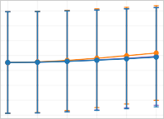
0.0 0.2 0.4 0.6 0.8 1.0

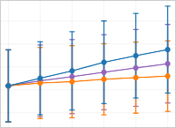
0.0 0.2 0.4 0.6 0.8 1.0

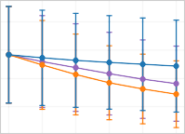
0.0 0.2 0.4 0.6 0.8 1.0

1.12

1.10

1.08

1.06

1.04

1.00

0.95

0.90

0.85

0.80

0.75

0.70

0.65

1.16

1.14

1.12

1.10

1.08

1.06

1.04

Bank
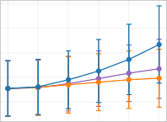
0.0 0.2 0.4 0.6 0.8 1.0

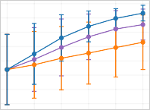
0.0 0.2 0.4 0.6 0.8 1.0

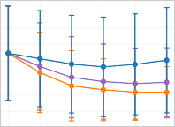
0.0 0.2 0.4 0.6 0.8 1.0

9.0

8.8

8.6

8.4

5.0

4.5

4.0

3.5

3.0

2.5

2.0

1.5

10.25

10.00

9.75

9.50

9.25

9.00

Credit
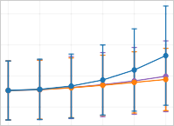
0.0 0.2 0.4 0.6 0.8 1.0

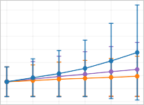
0.0 0.2 0.4 0.6 0.8 1.0

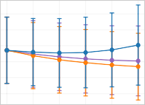
0.0 0.2 0.4 0.6 0.8 1.0

22.40

22.35

22.30

22.25

22.20

1.7

1.6

1.5

1.4

1.3

1.2

23.2

23.0

22.8

22.6

22.4

Student
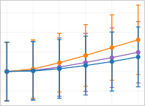
0.0 0.2 0.4 0.6 0.8 1.0

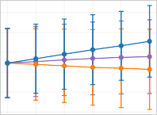
0.0 0.2 0.4 0.6 0.8 1.0

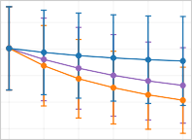
0.0 0.2 0.4 0.6 0.8 1.0

Balanced ( sep = soc) Separation-heavy ( sep = 3 /4) Social-heavy ( soc = 3 /4)

Fig. 4: k-means cost, separation fairness and social cost for UniFair k-means across datasets and λ values for different fairness weight configurations.

λ/2, a setting with greater emphasis on separation fairness (λ_{sep} = 3λ/4), and a setting with greater emphasis on social fairness (λ_{soc} = 3λ/4).
Figure shows the clustering cost, the separation fairness, and the maxi-
4
mum social cost, obtained by the UniFair algorithm across datasets and dif- ferent values of λ for the three weighting cases. Overall, we observe that the balanced setting (λ_{sep} = λ_{soc} = λ/2) achieves a good compromise between the two fairness notions, maintaining moderate values for both separation and social fairness while keeping the clustering cost relatively stable. When more weight is assigned to separation fairness (λ_{sep} = 3λ/4), the separation fairness cost im- proves consistently as λ increases, while the social fairness cost slightly increases. Conversely, when more weight is assigned to social fairness (λ_{soc} = 3λ/4), the social fairness cost decreases, indicating improved balance between demographic groups, while the separation fairness cost tends to increase slightly.

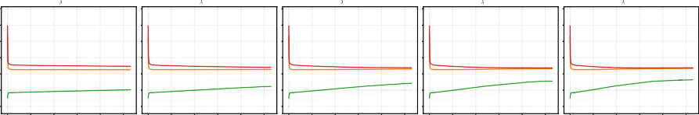1.8
= 0.2
= 0.4
= 0.6
= 0.8
= 1.0

1.6

1.4

1.2
Loss

1.0

0.8

0.6

0 100 200 300 400 500
Iterations

0 100 200 300 400 500
Iterations

0 100 200 300 400 500
Iterations

0 100 200 300 400 500
Iterations

0 100 200 300 400 500
Iterations

k-means Loss Social Loss Separation Loss

Fig. 5: UniFair loss curves across iterations for λ values on the Bank dataset.

Figure shows the evolution of the clustering, separation, and social losses
5
of the UniFair objective during training for different values of λ on the Bank dataset. We observe that the optimization process converges rapidly within the first iterations and stabilizes afterwards for all values of λ. As λ increases, the separation loss increases as it is maximized during optimization, while the so- cial loss decreases. The clustering loss remains relatively stable across iterations and across different λ values, indicating that improvements in fairness can be achieved without significantly affecting clustering quality. Overall, these results demonstrate that jointly optimizing separation and social fairness improves fair- ness across both criteria while preserving clustering performance.

RQ3: How does UniFair perform on multidimensional data?
To evaluate the effectiveness of UniFair on high-dimensional visual data, we conduct experiments on the MNIST–USPS and Color Reverse MNIST datasets. Figure 6 shows the k-means cost, separation fairness, and social cost across different values of λ and for different fairness weight configurations.

0.60

0.50
MNIST-USPS

0.40

0.30

0.20

0.10

0.00

0.30
Color Reverse MNIST

0.25

0.20

0.15

0.10

0.05

0.00

k-means cost

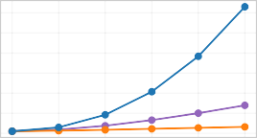
0 0.2 0.4 0.6 0.8 1

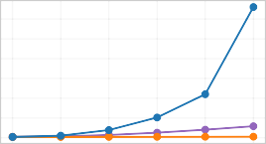
0 0.2 0.4 0.6 0.8 1

2.50

2.00

1.50

1.00

0.50

1.20

1.00

0.80

0.60

0.40

0.20

Separation Fairness

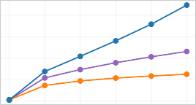
0 0.2 0.4 0.6 0.8 1

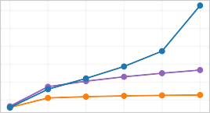
0 0.2 0.4 0.6 0.8 1

0.60

0.50

0.40

0.30

0.20

0.10

0.00

0.35

0.30

0.25

0.20

0.15

0.10

0.05

0.00

Social Cost

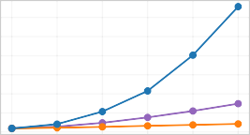
0 0.2 0.4 0.6 0.8 1

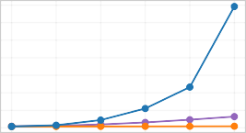
0 0.2 0.4 0.6 0.8 1

Balanced ( sep = soc) Separation-heavy ( sep = 3 /4) Social-heavy ( soc = 3 /4)

Fig. 6: k-means cost, separation fairness and social cost for UniFair for different fairness weight configurations on MNIST-USPS and Color Reverse MNIST.

As λ increases, fairness improves while the clustering cost rises moderately, particularly when separation fairness is emphasized. For both datasets, the so- cial cost is already close to zero for small λ, indicating balanced clustering costs across groups even without strongly enforcing social fairness. Introducing separa- tion fairness shifts cluster boundaries and centroids, which may slightly increase the social cost in the balanced setting. Assigning more weight to social fair- ness corrects these imbalances. Overall, the fairness weights provide flexibility to adjust the relative importance of the two criteria depending on the dataset, allowing improvements in both fairness notions.
As no prior deep fair clustering approach addresses our fairness notions, we compare with Deep Fair Clustering (DFC) [11]. DFC enforces independence be-

Table 1: Comparison with the DFC method.
Separation Fairness Social Cost Dataset Method NMI Group A Group B Group A Group B
UniFair 0.66 1.16 1.12 0.06 0.07
MNIST-USPS DFC 0.69 248.08 243.08 0.26 0.59

tween cluster assignments and the protected attribute, rather than explicitly optimizing the notions of separation fairness and social fairness. DFC learns fair representations through adversarial training, where an encoder produces cluster- ing representations while a discriminator predicts the sensitive attribute. Table 1 reports clustering quality (NMI), separation fairness, and social cost for our algorithm and the DFC method on the MNIST–USPS dataset, which is the only dataset with available pretrained models for this method. For our algorithm we use the balanced setting λ_{soc} = λ_{sep} = λ/2. DFC achieves the highest clustering quality (NMI=0.69), though the performance of our methods remains very close. As the methods rely on different representation learning architectures, distance scales are not directly comparable, thus we focus on relative group differences. The UniFair method shows balanced behavior, with minor differences among groups in both separation and social fairness values while preserving competitive clustering quality. In contrast, DFC exhibits a noticeable discrepancy between the groups, particularly in the social cost metric, suggesting that although it achieves strong clustering performance and enforces independence between clus- ter assignments and the protected attribute, it does not satisfy the separation and social fairness notions considered in our work.

6 Conclusions

In this work, we proposed separation fair k-means, which encourages demo- graphic groups to lie at similar distances from cluster decision boundaries, and the UniFair algorithm, which jointly optimizes separation and social fairness. We extended both approaches to deep clustering by enforcing these criteria in the latent space. Our experimental results on both tabular and high dimensional image data demonstrate that the proposed methods effectively improve separa- tion fairness and reduce social cost while maintaining the clustering quality. The results also show that separation fairness and social fairness capture different types of unfairness, and that the UniFair algorith allows flexible balancing be- tween the two criteria.

References

- Abbasi, M., Bhaskara, A., Venkatasubramanian, S.: Fair clustering via equitable group representations. In: ACM FAccT. pp. 504–514 (2021)

- Ahmadi, S., Galhotra, S., Saha, B., Schwartz, R.: Fair correlation clustering. arXiv (2020)
- Anderson, N., Bera, S.K., Das, S., Liu, Y.: Distributional individual fairness in clustering. arXiv (2020)
- Bera, S., Chakrabarty, D., Flores, N., Negahbani, M.: Fair algorithms for clustering. In: NeurIPS (2019)
- Chhabra, A., Masalkovaite, K., Mohapatra, P.: An overview of fairness in cluster- ing. IEEE Access 9, 130698–130720 (2021)
- Chierichetti, F., Kumar, R., Lattanzi, S., Vassilvitskii, S.: Fair clustering through fairlets. In: NeurIPS (2017)
- Ghadiri, M., Samadi, S., Vempala, S.: Socially fair k-means clustering. In: ACM FAccT. pp. 438–448 (2021)
- Goyal, D., Jaiswal, R.: Tight fpt approximation for socially fair clustering. Infor- mation Processing Letters 182, 106383 (2023)
- Kleindessner, M., Awasthi, P., Morgenstern, J.: A notion of individual fairness for clustering. arXiv (2020)
- Lawless, C., Gunluk, O.: Fair minimum representation clustering. In: CPAIOR. LNCS, vol. 14743, pp. 20–37 (2024)
- Li, P., Zhao, H., Liu, H.: Deep fair clustering for visual learning. In: CVPR. pp. 9070–9079 (2020)
- Makarychev, Y., Vakilian, A.: Approximation algorithms for socially fair clustering. In: COLT. pp. 3246–3264 (2021)
- Schmidt, M., Schwiegelshohn, C., Sohler, C.: Fair coresets and streaming algo- rithms for fair k-means clustering. arXiv (2018)
- Vardakas, G., Karra, A., Pitoura, E., Likas, A.: Counterfactual explanations for k-means and gaussian clustering. In: ICTAI. pp. 977–983 (2025)
- Wang, B., Davidson, I.: Towards fair deep clustering with multi-state protected variables. arXiv (2019)
- Zhang, H., Davidson, I.: Deep fair discriminative clustering. arXiv (2021)

